RESTRICTED IDLING SIGNS

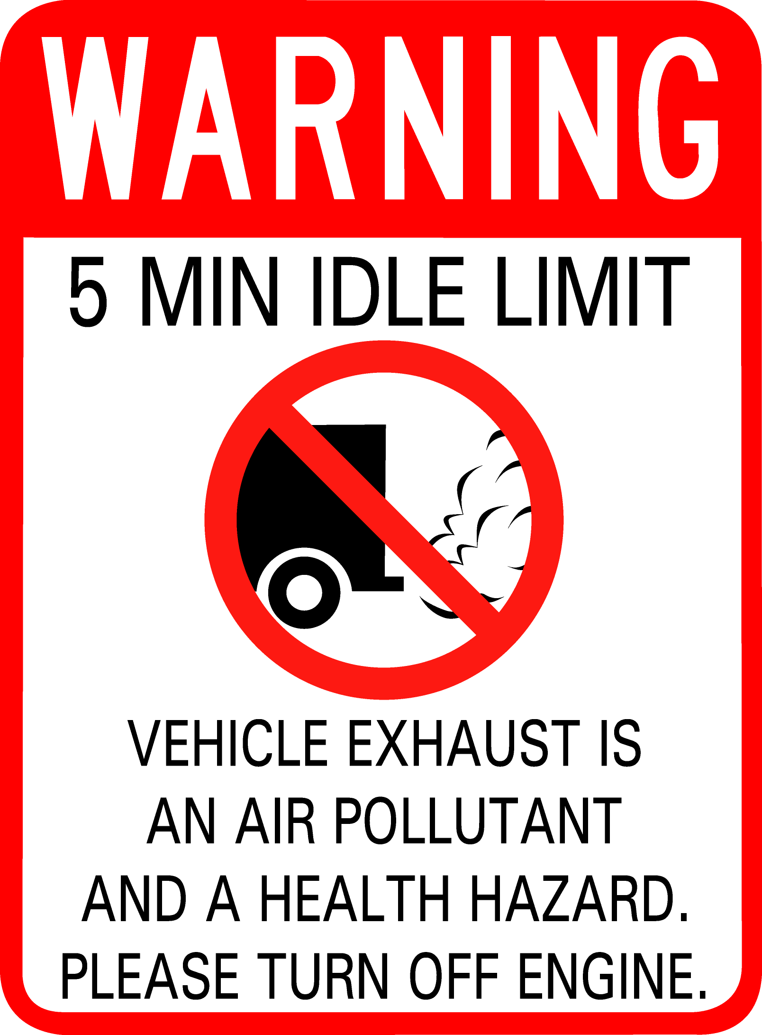
As part of our regional O₃ Flex and Clean Air Action Plan commitments, The City of Austin Air Quality Program has developed a no-idling sign for posting in loading dock and other suitable areas. We are happy to assist other signatories and supporting organizations that would like to post restrictions on vehicle idling, and offer the following options:

- We can provide scalable vector artwork for your sign shop in Adobe Illustrator (AI) or EPS format. If your sign shop cannot accept artwork in these formats, we can work with you on a limited basis to adapt the sign for your production needs.

- You can purchase signs through an outside vendor. There are local and national custom sign vendors offering a range of materials and sizes. Some options may reduce cost (non-reflective, lightweight materials, etc.), depending on your group’s needs. If you choose to work with an outside vendor, COA assistance is limited to providing AI or EPS artwork only (no staff time available).

- You may purchase signs directly from the City of Austin sign shop. Signs measure 18” x 24” and are produced in two colors on high-intensity, 0.08 gauge aluminum with two holes drilled for mounting.

- 5 sign minimum
- Orders < 20: $55 per sign; larger orders $50 per sign
- Delivery estimate upon order; allow at least 3 weeks for production
- Orders must be picked up from the COA sign shop, or prior arrangements made
- Contact City of Austin’s Air Quality Program: airquality@ci.austin.tx.us or 512.482.5341

